**LOGIN PAGE**

This page is essential to the whole app, this page allows users to access their specified account.

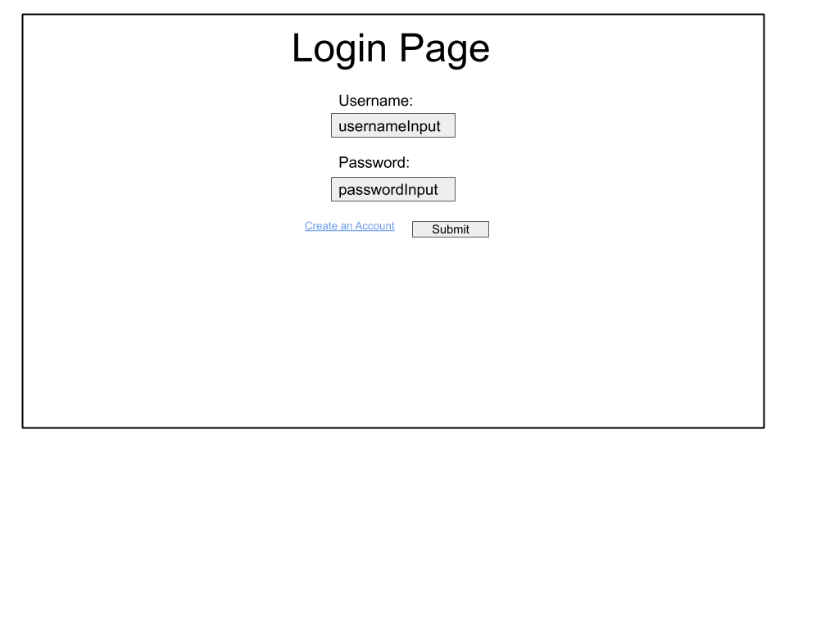

**usernameInput** - This is where the user will input their credentials to gain access to their account.

**passwordInput** - This is where the user inputs their password to access their account.

**Create an Account link** - Allows the new users to create an account via a separate form.

**Submit button** - When a user clicks this, the details entered will be compared to what is in the database, if they match then the user will be able to continue and access information from their Spotify account. If not then they will be rejected from entering the system.

**CREATE AN ACCOUNT PAGE**

This page allows a user to enter details in order to create a new account in the database.

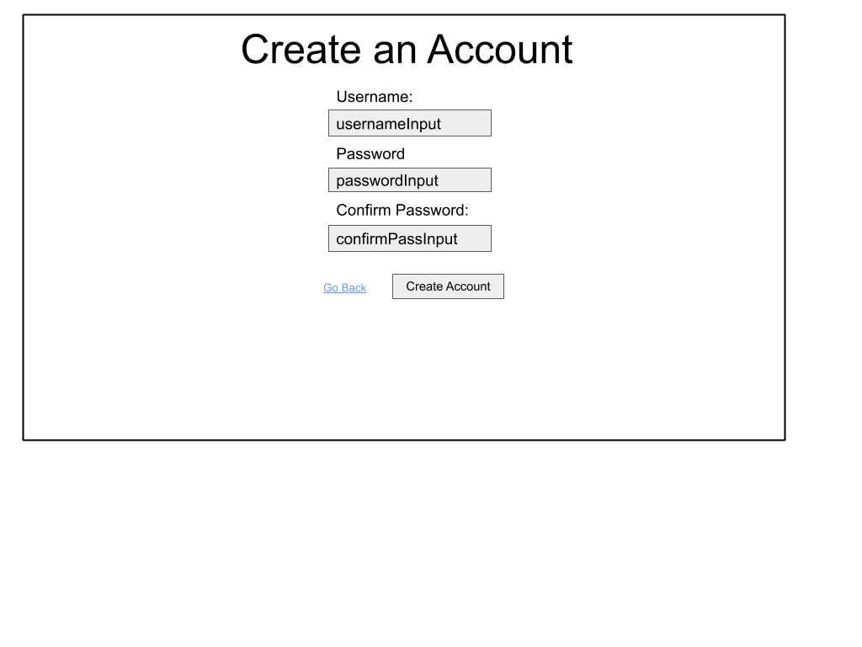

**usernameInput** - Allows a user to enter a username of their choosing, this username is compared to all usernames on the database to see if it exists already, if it doesn’t then the user will get that username, otherwise the user will have to come up with another username.

**passwordInput** - Allows a user to input a password in order to access their data and account later on.

**confirmPassInput** - The user must confirm the password they previously entered, this is a verification stage once the Create Account button is pressed, this is so incorrect data is not inputted into the database.

**Go Back link** - This link ignores all that has been entered into the form and simply returns to the login page.

**Create Account button** - This button will check for empty fields, compare the username to all usernames in the database and verify that the user has inputted the correct passwords. These are all checks so invalid data does not get into the system. If it passes all, then data will be saved to the database and the the user will be shown back to the login page.